**Main Tables and Figures**

**Table 1: Baseline characteristics of the study sample (n=47,913)**

|  |  |  |
| --- | --- | --- |
| **Characteristic** | **n (%)** | **Number of DTC cases** |
| Age (median, interquartile range) | 55.4 (48.9, 62.1) | 239 |
| Self-identified race/ethnicity |  |  |
| Non-Hispanic White | 39,947 (83%) | 207 |
| Non-Hispanic Black | 4,304 (9%) | 9 |
| Hispanic | 2,416 (5%) | 18 |
| Non-Hispanic all other races | 1,231 (3%) | 5 |
| Unknown | 15 (<0.1%) | 0 |
| BMI |  |  |
| <25.0 | 18,331 (38%) | 83 |
| 25.0-29.9 | 15,205 (32%) | 74 |
| ≥30.0 | 14,361 (30%) | 82 |
| Unknown | 16 (<0.1%) | 0 |
| Benign thyroid disease | 10,308 (22%) | 60 |
| Personal attained education level |  |  |
| High school, GED, or less | 7,290 (15%) | 29 |
| Some college or associate or technical degree | 16,161 (34%) | 80 |
| Bachelor’s degree or more | 24,450 (51%) | 130 |
| Unknown | 12 (<0.1%) | 0 |
| Annual household income |  |  |
| <$50,000 | 12,228 (26%) | 61 |
| $50,000-$99,999 | 19,552 (41%) | 94 |
| ≥$100,000 | 16,133 (34%) | 84 |

BMI: body mass index (kg/m2)

GED: General Educational Development

**Table 2: Association between childhood and adolescent factors and differentiated thyroid cancer incidence in the Sister Study cohort**

|  |  |  |  |  |  |
| --- | --- | --- | --- | --- | --- |
| **Characteristic** |  | **Multivariable models** | | | |
| **Total cohort, N (%)** | **DTC cases, N** | **Person-years** | **HR***1* | **95% CI***1* |
| **Growth and reproductive factors** |  |  |  |  |  |
| Relative weight to peers at age 10 |  |  |  |  |  |
| Lighter | 16,793 (35%) | 80 | 203,318 | 1.03 | 0.77, 1.38 |
| Same weight | 22,324 (47%) | 105 | 271,626 | 1 | — |
| Heavier | 8,644 (18%) | 52 | 106,503 | 1.25 | 0.90, 1.75 |
| Height relative to peers at age 10 |  |  |  |  |  |
| Shorter | 12,285 (26%) | 53 | 150,199 | 0.94 | 0.68, 1.32 |
| Same height | 21,984 (46%) | 99 | 266,794 | 1 | — |
| Taller | 13,556 (28%) | 87 | 165,201 | 1.41 | 1.06, 1.89 |
| Weight relative to peers during teen years |  |  |  |  |  |
| Lighter | 16,658 (35%) | 90 | 201,757 | 1.28 | 0.96, 1.71 |
| Same weight | 22,461 (47%) | 97 | 273,839 | 1 | — |
| Heavier | 8,735 (18%) | 52 | 106,906 | 1.37 | 0.97, 1.91 |
| Age at breast development |  |  |  |  |  |
| <11 years of age | 6,352 (13%) | 32 | 76,904 | 1.04 | 0.71, 1.52 |
| 11-13 years of age | 32,749 (68%) | 160 | 399,844 | 1 | — |
| ≥14 years of age | 8,233 (17%) | 44 | 99,796 | 1.11 | 0.79, 1.55 |
| Age at breast development (continuous, imputed, median, IQR) | 12.0 (11.0, 13.0) | 239 | 583,135 | 1.00 | 0.94, 1.06 |
| Age at menarche |  |  |  |  |  |
| <12 years of age | 9,735 (20%) | 55 | 117,128 | 1.16 | 0.85, 1.59 |
| 12-13 years of age | 26,875 (56%) | 134 | 328,470 | 1 | — |
| ≥14 years of age | 11,246 (24%) | 50 | 136,821 | 0.89 | 0.64, 1.23 |
| Age at menarche (continuous, imputed, median, IQR) | 13.0 (12.0, 13.0) | 239 | 583,135 | 0.98 | 0.91, 1.06 |
| Age started using hormonal birth control |  |  |  |  |  |
| Never before age 20 | 26,046 (54%) | 130 | 315,004 | 1 | — |
| Ever before age 20 | 20,864 (44%) | 105 | 256,147 | 0.94 | 0.72, 1.24 |
| **Lifestyle factors** |  |  |  |  |  |
| Physical activity between age 5 and 20 (MET-hours/week) |  |  |  |  |  |
| <21 MET-hours/week | 41,526 (87%) | 209 | 506,471 | 1 | — |
| 21-<42 MET-hours/week | 3,964 (8%) | 22 | 47,968 | 1.09 | 0.70, 1.69 |
| ≥42 MET-hours/week | 2,100 (4%) | 5 | 25,155 | 0.47 | 0.19, 1.14 |
| Physical activity between age 5 and 20 (MET-hours/week, continuous, imputed, median, IQR) | 1.8 (0.0, 10.0) | 239 | 583,135 | 0.99 | 0.98, 1.00 |
| Age started drinking regularly |  |  |  |  |  |
| Never before age 20 | 14,977 (31%) | 66 | 178,111 | 1 | — |
| Ever before age 20 | 32,905 (69%) | 173 | 404,665 | 1.09 | 0.81, 1.47 |
| Number of drinks per year between age 5 and 20 (drinks/year) |  |  |  |  |  |
| 0 drink/year | 15,136 (32%) | 66 | 179,860 | 1 | — |
| <60 drinks/year | 14,083 (29%) | 74 | 174,500 | 1.11 | 0.79, 1.55 |
| 60-229 drinks/year | 8,983 (19%) | 38 | 111,049 | 0.86 | 0.57, 1.30 |
| ≥230 drinks/year | 5,269 (11%) | 33 | 64,920 | 1.25 | 0.80, 1.93 |
| Age started smoking and number of pack-years |  |  |  |  |  |
| Never before age 20 | 32,020 (67%) | 156 | 393,059 | 1 | — |
| Ever before age 20 | 15,874 (33%) | 83 | 189,859 | 1.11 | 0.85, 1.45 |
| Ever before age 20, ≤5 pack-years | 14,852 (31%) | 78 | 177,875 | 1.11 | 0.85, 1.46 |
| Ever before age 20, >5 pack-years | 914 (2%) | 5 | 10,802 | 1.15 | 0.47, 2.80 |
| Total years of secondhand smoking under age 18 from caregiver or household member |  |  |  |  |  |
| No secondhand smoking during childhood | 13,867 (29%) | 72 | 169,783 | 1 | — |
| ≤10 years | 6,258 (13%) | 30 | 76,550 | 0.94 | 0.61, 1.44 |
| >10 years | 26,919 (56%) | 133 | 326,740 | 0.99 | 0.74, 1.32 |
| **Socioeconomic factors** |  |  |  |  |  |
| Family income while growing up |  |  |  |  |  |
| Well off | 3,066 (6%) | 13 | 37,935 | 0.78 | 0.44, 1.37 |
| Middle income | 28,582 (60%) | 152 | 351,548 | 1 | — |
| Low income | 12,350 (26%) | 56 | 148,793 | 0.91 | 0.67, 1.24 |
| Poor | 3,799 (8%) | 17 | 43,676 | 0.96 | 0.58, 1.61 |
| Ever not having enough to eat during childhood |  |  |  |  |  |
| No | 43,388 (91%) | 206 | 531,069 | 1 | — |
| Yes | 4,492 (9%) | 33 | 51,706 | 1.67 | 1.15, 2.43 |
| Highest household education level at age 13 |  |  |  |  |  |
| Highschool or GED or less | 25,729 (54%) | 134 | 307,924 | 1 | — |
| Some college or associate or technical degree | 8,889 (19%) | 45 | 109,360 | 0.93 | 0.66, 1.30 |
| Bachelor's degree or higher | 12,736 (27%) | 56 | 159,924 | 0.75 | 0.55, 1.03 |
| Family type at age 13 |  |  |  |  |  |
| Two parents | 42,700 (89%) | 220 | 522,033 | 1 | — |
| Single parent | 4,669 (10%) | 15 | 54,984 | 0.68 | 0.40, 1.15 |
| Childhood urbanicity |  |  |  |  |  |
| Urban or suburban areas | 24,001 (50%) | 126 | 294,128 | 1 | — |
| Small town or rural areas | 23,207 (48%) | 111 | 280,828 | 0.93 | 0.72, 1.20 |
| HR = Hazard Ratio, CI = Confidence Interval |  |  |  |  |  |
| *1* Multivariable models used attained age as the timescale and were adjusted for self-identified race/ethnicity | | | | | |
| Results for “Unknown” categories are not shown. The number of observations within the “Unknown” categories for each variable is as follows: Weight relative to peers at age 10 (n=152), Height relative to peers at age 10 (n=88), Weight relative to peers during teen years (n=59), Age at breast development (n=579), Age at menarche (n=57), Age started using hormonal birth control (n=1,003), Physical activity between age 5 and 20 (MET-hours/week) (n=323), Age started drinking regularly (n=31), Number of drinks per year between age 5 and 20 (drinks/year) (n=4,442), Total years of secondhand smoking under age 18 from caregiver or household member (n=869), Family income while growing up (n=116), Ever not having enough to eat during childhood (n=33), Highest household education level at age 13 (n=559), Household composition at age 13 (n=544), Childhood urbanicity (n=705). | | | | | |

**Table 3: Mutually adjusted associations between for selected factors and differentiated thyroid cancer incidence**

|  |  |  |  |  |  |
| --- | --- | --- | --- | --- | --- |
| **Characteristic** | **DTC cases, N** | **Model 1** | | **Model 2** | |
| **HR** | **95% CI** | **HR** | **95% CI** |
| Height relative to peers at age 10 |  |  |  |  |  |
| Shorter | 53 | 0.9 | 0.64, 1.26 | 0.89 | 0.64, 1.25 |
| Same height | 99 | 1 | — | 1 | — |
| Taller | 87 | 1.39 | 1.04, 1.86 | 1.38 | 1.03, 1.85 |
| Unknown | 0 | — | — | — | — |
| Weight relative to peers during teen years |  |  |  |  |  |
| Lighter | 90 | 1.29 | 0.96, 1.72 | 1.29 | 0.97, 1.73 |
| Same weight | 97 | 1 | — | 1 | — |
| Heavier | 52 | 1.3 | 0.93, 1.83 | 1.31 | 0.93, 1.83 |
| Unknown | 0 | — | — | — | — |
| Ever not having enough to eat during childhood |  |  |  |  |  |
| No | 206 | 1 | — | 1 | — |
| Yes | 33 | 1.58 | 1.08, 2.31 | 1.90 | 1.25, 2.88 |
| Unknown | 0 | — | — | — | — |
| Highest household education level at age 13 |  |  |  |  |  |
| Highschool or GED or less | 134 | 1 | — | 1 | — |
| Some college or associate or technical degree | 45 | 0.94 | 0.67, 1.32 | 0.89 | 0.63, 1.26 |
| Bachelor's degree or higher | 56 | 0.77 | 0.56, 1.07 | 0.71 | 0.51, 1.00 |
| Unknown | 4 | 1.8 | 0.66, 4.88 | 1.72 | 0.62, 4.77 |
| HR = Hazard Ratio, CI = Confidence Interval |  |  |  |  |  |
| Model 1 was simultaneously adjusted for attained age (timescale), self-identified race/ethnicity, height relative to peers at age 10, and weight relative to peers during teen years, ever not having enough to eat during childhood, and highest household education level at age 13. Model 2 was simultaneously adjusted for all covariates of model 1 and family income while growing up, family type at age 13, and childhood urbanicity | | | | | |

## Figure 1: The joint associations of weight relative to peers during teen years and baseline BMI with differentiated thyroid cancer incidence

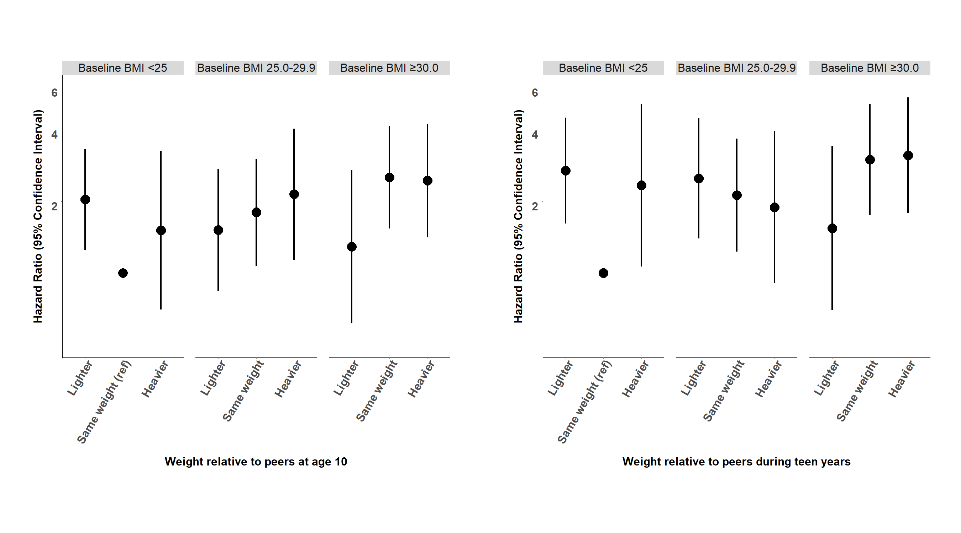

**Supplementary materials**

## Supplementary Figure 1: Association between height relative to peers at age 10, weight relative to peers during teen years, ever not having enough to eat during childhood, and highest household education level at age 13 and differentiated thyroid cancer incidence in the Sister Study participants stratified according to potential modifying factors at baseline

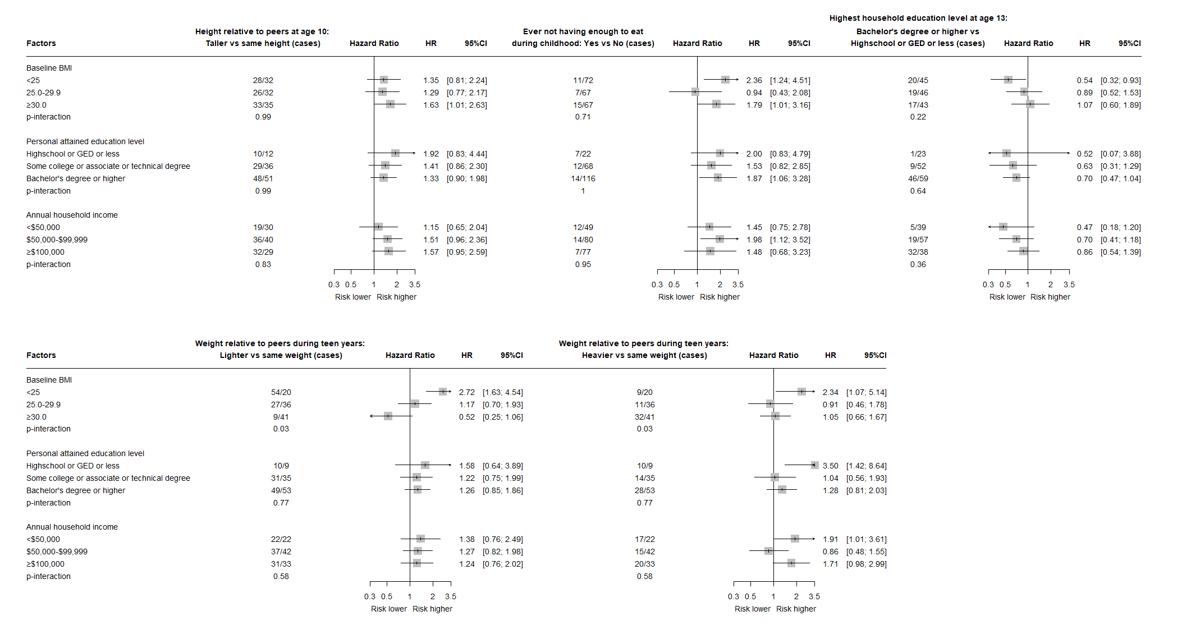

## Supplementary table 1: The joint associations of weight relative to peers during teen years and baseline BMI with differentiated thyroid cancer incidence

|  |  |  |  |  |
| --- | --- | --- | --- | --- |
| **Baseline BMI** | **Weight relative to peers during teen years** | **Number of events** | **HR***1* | **95% CI***1* |
| <25 | Lighter | 54 | 2.7 | 1.61, 4.50 |
|  | Same weight | 20 | 1 | — |
|  | Heavier | 9 | 2.34 | 1.06, 5.13 |
| 25.0-29.9 | Lighter | 27 | 2.5 | 1.40, 4.47 |
|  | Same weight | 36 | 2.12 | 1.23, 3.67 |
|  | Heavier | 11 | 1.89 | 0.91, 3.95 |
| ≥30.0 | Lighter | 9 | 1.55 | 0.70, 3.41 |
|  | Same weight | 41 | 3 | 1.75, 5.12 |
|  | Heavier | 32 | 3.13 | 1.79, 5.48 |
| 1HR = Hazard Ratio, CI = Confidence Interval  Multivariable models used attained age as the timescale and were adjusted for self-identified race/ethnicity | | | | |

## Supplementary table 2: The joint associations of weight relative to peers at age 10 and baseline BMI with differentiated thyroid cancer incidence

|  |  |  |  |  |
| --- | --- | --- | --- | --- |
| **Baseline BMI** | **Weight relative to peers at age 10** | **Number of events** | **HR***1* | **95% CI***1* |
| <25 | Lighter | 49 | 2.04 | 1.25, 3.32 |
|  | Same weight | 24 | 1 | — |
|  | Heavier | 9 | 1.51 | 0.70, 3.25 |
| 25.0-29.9 | Lighter | 21 | 1.52 | 0.84, 2.73 |
|  | Same weight | 36 | 1.80 | 1.07, 3.02 |
|  | Heavier | 16 | 2.14 | 1.14, 4.04 |
| ≥30.0 | Lighter | 10 | 1.29 | 0.62, 2.71 |
|  | Same weight | 45 | 2.53 | 1.54, 4.16 |
|  | Heavier | 27 | 2.45 | 1.41, 4.25 |
| 1HR = Hazard Ratio, CI = Confidence Interval  Multivariable models used attained age as the timescale and were adjusted for self-identified race/ethnicity | | | | |

**Supplementary table 3: Association between childhood and adolescent factors and differentiated thyroid cancer incidence in the Sister Study participants: sensitivity analyses**

|  |  |  |  |  |  |  |  |  |  |  |  |  |  |  |  |
| --- | --- | --- | --- | --- | --- | --- | --- | --- | --- | --- | --- | --- | --- | --- | --- |
| **Characteristic** | **Early-onset cancers** | | | **Late-onset cancers** | | | | **Medically confirmed DTC cases** | | | **Papillary thyroid cancer** | | | **E-values** | |
|  | **Cases** | **HR** | **95% CI** | | **Cases** | **HR** | **95% CI** | **Cases** | **HR** | **95% CI** | **Cases** | **HR** | **95% CI** | **E-values for HR** | **E-values for CI1** |
| Height relative to peers at age 10 | | | |  | |  |  |  |  |  |  |  |  |  |  |
| Shorter | 9 | 1.18 | 0.50, 2.75 | | 44 | 0.91 | 0.63, 1.31 | 43 | 1.05 | 0.72, 1.54 | 41 | 1.1 | 0.74, 1.62 | 1.31 | 1 |
| Same height | 13 | 1 | — | | 86 | 1 | — | 72 | 1 | — | 66 | 1 | — |  |  |
| Taller | 17 | 2.05 | 0.99, 4.23 | | 70 | 1.32 | 0.96, 1.81 | 60 | 1.34 | 0.95, 1.88 | 57 | 1.38 | 0.97, 1.97 | 2.18 | 1.31 |
| Unknown2 | 0 | — | — | | 0 | — | — | 0 | — | — | 0 | — | — |  |  |
| Weight relative to peers during teen years | | |  | |  |  |  |  |  |  |  |  |  |  |  |
| Lighter | 14 | 1.17 | 0.57, 2.41 | | 76 | 1.3 | 0.95, 1.78 | 71 | 1.52 | 1.08, 2.12 | 67 | 1.56 | 1.10, 2.21 | 1.88 | 1 |
| Same weight | 16 | 1 | — | | 81 | 1 | — | 65 | 1 | — | 60 | 1 | — |  |  |
| Heavier | 9 | 1.26 | 0.56, 2.85 | | 43 | 1.38 | 0.96, 2.00 | 39 | 1.53 | 1.03, 2.27 | 37 | 1.56 | 1.04, 2.36 | 2.07 | 1 |
| Unknown2 | 0 | — | — | | 0 | — | — | 0 | — | — | 0 | — | — |  |  |
| Ever not having enough to eat during childhood | | | |  | |  |  |  |  |  |  |  |  |  |  |
| No | 32 | 1 | — | | 174 | 1 | — | 155 | 1 | — | 146 | 1 | — |  |  |
| Yes | 7 | 2.05 | 0.87, 4.79 | | 26 | 1.6 | 1.05, 2.42 | 20 | 1.36 | 0.85, 2.19 | 18 | 1.32 | 0.80, 2.17 | 2.73 | 1.56 |
| Unknown2 | 0 | — | — | | 0 | — | — | 0 | — | — | 0 | — | — |  |  |
| Highest household education level at age 13 | | | |  | |  |  |  |  |  |  |  |  |  |  |
| Highschool or GED or less | 21 | 1 | — | | 113 | 1 | — | 98 | 1 | — | 92 | 1 | — |  |  |
| Some college or associate or technical degree | 9 | 1.08 | 0.49, 2.39 | | 36 | 0.89 | 0.61, 1.30 | 31 | 0.86 | 0.58, 1.30 | 29 | 0.86 | 0.56, 1.30 | 1.38 | 1 |
| Bachelor's degree or higher | 8 | 0.58 | 0.26, 1.28 | | 47 | 0.8 | 0.57, 1.13 | 43 | 0.78 | 0.54, 1.13 | 40 | 0.77 | 0.53, 1.12 | 1.99 | 1.22 |
| Unknown2 | 0 | — | — | | 4 | — | — | 3 | — | — | 3 | — | — | — | — |
| HR = Hazard Ratio, CI = Confidence Interval. The risk estimates are shown when there were at least 5 cases.  Multivariable models used attained age as the timescale and were adjusted for self-identified race/ethnicity  *1* E-values for the limit of the confidence interval closest to the null  2 Results for “Unknown” categories of are not shown | | | | | | | | | | | | | | | |